August 20th, 2006
Hi to All
Well, I am now back having been in Singapore for 8 days. The first interesting thing I noticed is that my breathing problems disappeared within hours of arrival there. A couple of days before leaving HK, I had dosed up on both prednisilone and theophylline. These made breathing easier but the side effects were not pleasant. Though I took both of these medicines to Singapore with me, I did not need them once. However, I still took the regular inhalation once a day but only used the reliever inhaler twice and probably did not really need to have. What is the reason? My guess is that it is probably air pollution. Singapore does not suffer from polluted air as HK does. (In fact, in the Chemistry book I revised, there is a topic on air pollution and I tried, unsuccessfully, to include an example of a day when the air pollution index in Singapore was not good.) On the other hand, the reason might be work. I did not have to work very hard while there, but that would not account for the problems disappearing almost immediately.
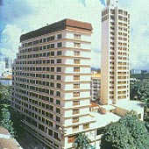
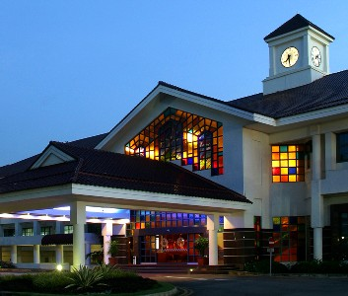
The hotel I, and other authors, stayed at (see top photo) was not one of the best. Nevertheless, it was OK. Unfortunately, the room had a door linking it with the adjacent room, which allows sounds to be transmitted more easily than a concrete wall. However, this was only a problem on two nights when a family (perhaps from HK, as they were speaking Cantonese) had very noisy kids and would come in late. However, after a thump on the wall, they were not too bad. While there, food patterns were the reverse of normal and I probably ate too much. Each day began with a buffet breakfast and I did eat a lot. I enjoyed eating bacon, which I do not eat now. Then the company took me out every day for lunch (except Sunday which was a free day), and on two of these days, it was a buffet lunch! In the evenings, I did not need to eat anything at all! On returning to HK, I weighed myself and found that I had added about 6 lbs. The second photo shows one of the country clubs where I had lunch on two occasions – one Japanese, the other Western. The Western meal was interesting; it was a set menu, but only the main course was served, with soup, vegetable dish and dessert being buffet style.
After breakfast each day, I took a taxi to the publishers’ offices (fares will be reimbursed). Most of the first two days were spent on preparing for the Chemistry book presentation on the Saturday. However, I also had to do part of the Physics presentation, not that it was difficult to do. Normally, the textbook presentations just involve talking about the features of the books. However, this can be rather boring. Therefore, when I last made a presentation, in 2001, I combined features of the books with the underlying educational psychology principles behind the use of them, together with how the books could be used for effective teaching and learning using these principles. As the physics author could not do this, I did it for him. The presentations went OK, except for the Chemistry presentation where the person operating the PowerPoint slides began to show the physics slides and had to get someone else to find the chemistry slides! This approach does seem to be more interesting with teachers telling me later than they enjoyed it with one even being ‘inspired’ by it. However, I did take longer than the allotted time, which meant the three science presentations (there was also Biology), which were in the same room, ended much later than scheduled.
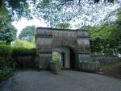
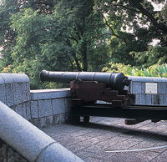
Sunday, as mentioned, was a free day. I had a look around a hilly park area called Fort Canning, which was the home of Malay kings about 700 years ago and later a British military fort. It includes the World War II British command bunker (entrance shown in photo) where they surrendered to the Japanese (I think) but I did not go in. A very heavy shower occurred while in the park but I found a shelter. Then I walked down to Chinatown, which was not very interesting. Then I took free buses over to ‘Little India.’ Again, not that interesting, as I had visited it before.
On the final morning, I went to a school to promote the chemistry books. Later, I was taken to the airport for the 7 pm flight back. With the airport problems in the UK and the US, I wondered what cabin luggage restrictions there might be for flights to HK. It turned out there was none. Arrived back in HK on time, which meant I just missed the 11 pm hotel bus. So, instead of waiting until midnight for the next bus, I took Bus E34 arriving back at 12:30 am, which was actually only 5 – 10 minutes before the midnight hotel bus would have arrived anyway.
While in Singapore, I did not do any exercise, though the hotel pool was quite nice and I thought about having a swim. On returning, I went for a swim. Just 1 km, but it felt like much more!
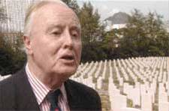
In HK, have you ever heard of Jack Edwards? He was A WWII veteran who was captured in Singapore, sent to work in mines in the Philippines, and was one of only about 50 out of about 540 who survived. Since he came to HK in 1963, he has been a fighter for better recognition and rights for WWII veterans. One of his biggest successes was to get BN(O) passports for local vets. Well, he died last Sunday, aged 88. The picture shows him at the Sai Wan military cemetery; this was the only picture of him I could find on the Internet. Interestingly, at his funeral, his coffin will be draped with the Union Jack flag that was the first to be flown in HK after the Japanese surrender (raised well before the British fleet returned) and was the same flag Patten chose for the handover ceremony. The flag was not originally Edwards’ but belonged to friend on his.
Last week in HK, before I went to Singapore, there was a 'Lights out at 8 pm' campaign to bring attention to the need to reduce pollution. It had mixed success but did achieve its purpose.
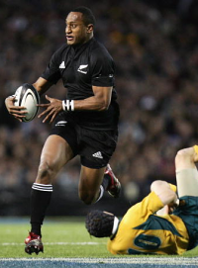
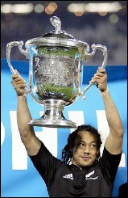
In the tri-nations yesterday, NZ beat Australia 3 4-27 in a very physical game in Auckland, which I watched on TV, and so clinched the tri-nations title (for the 7th time in 11 years) with two games still to go (both against SA in SA). NZ was down 20 – 11 at half time but outscored the Australians 23 – 7 in the second half. Of note was the ‘spear tackle’ made on the NZ captain. (A spear tackle is when a player is turned upside down and driven head first into the ground. Apparently, it is not illegal in Rugby Union though is in Rugby League, but the player can be cited for dangerous play, which he was.) After the game, NZ received the tri-nations cup. (Note that the second photo shows the cup being received last year; I could not find a picture for this year.)
That seems to be about it for now. Longer than usual.

Cheers

